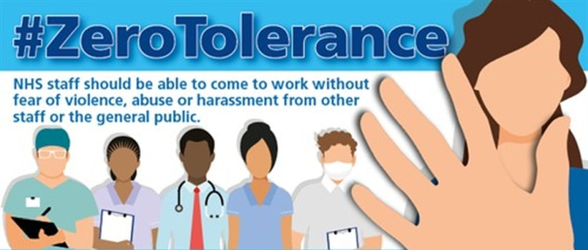

Dr Nagpal’s Surgery implements the NHS Zero Tolerance Policy.
We treat our patients with courtesy and respect and ask the same in return. GP’s and their staff have the right to care for others without fear of being attacked or abused. Any behaviour verbal or physical which causes staff to feel uncomfortable, embarrassed or threatened, is totally unacceptable.
Examples of Unacceptable Standards of Behaviour
- Violence.
- Excessive noise eg recurrent loud or intrusive conversation or shouting.
- Threatening or abusive language involving swearing or offence remarks.
- Derogatory racial or sexual remarks.
- Malicious allegations relating to members of staff, other patients or visitors.
- Offensive sexual gestures or behaviours.
- Abusing alcohol or drugs on practice premises.
- Drug dealing on practice premises.
- Wilful damage to practice property.
- Threats or threatening behaviour.
- Theft
This list is not exhaustive.
All incidents will be followed up with a formal warning, in extreme cases the Police will be contacted, and you will be removed from the practice list with immediate effect if deemed necessary.
If you are unhappy with the quality of our services you have the right to find the care you seek, and to re-register with another practice without notifying us. Similarly, when a patient repeatedly ignores their responsibilities to the Practice, we have the right to remove the patient from our Practice list.
Removal from the practice list
In exceptional circumstances, a breakdown may occur between a doctor and their patient. If the breakdown is of a serious nature e.g. aggression, threatening or abusive language, violence or serious physical insult to any member of the practice team, steps will be taken to have the patient removed from the list. It is in the patient’s interest, just as much as that of the practice that the patient should find a new practice.
Removing other members of the household
In rare cases, because of the possible need to visit patients at home it may be necessary to terminate the registration for other members of the family, or the entire household. The prospect of visiting patients where a relative (who is no longer a patient of the practice by virtue of their unacceptable behaviour) resides, or being regularly confronted by the removed patient, may make it too difficult for the practice to continue to look after the whole family.

